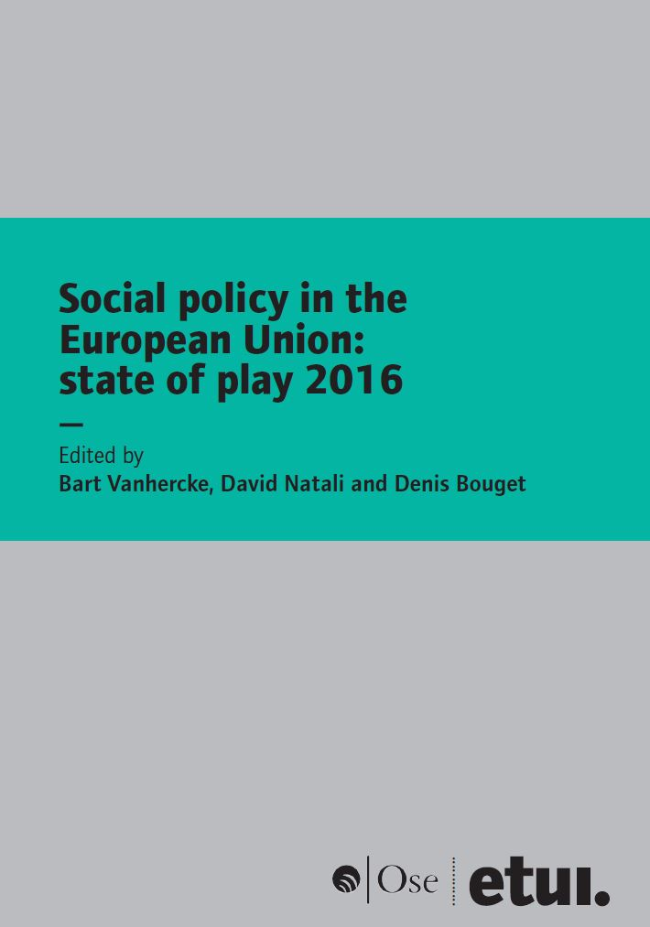 | The European Social Observatory (OSE) and the  European Trade Union Institute (ETUI) cordially invite  you to a conference marking the publication of  Social Policy in the European Union: State of Play 2016  Brussels, 27 February 2016 – 9.00 am - 1.00 pm  Event hosted by the Workers' Group of the EESC

Venue: European Economic and Social Committee (EESC), Jacques Delors Building,
rue Belliard 99, 1040 Brussels

Programme

8.30 Registration

9.00 am Quo vadis Social Europe ? Lessons from the ‘State of Play 2016’ book, followed by Q&A
Gabriele Bischoff, President, Worker’s Group, European Economic and Social Committee
Maxime Cerutti, Director, Social Affairs department, BusinessEurope
Esther Lynch, Confederal Secretary, European Trade Union Confederation
Philippe Pochet, General Director, European Trade Union Institute

Chair
Bart Vanhercke, Director, European Social Observatory (OSE)

9.45 am Key messages form ‘Social policy in the European Union: State of Play 2016’
David Natali, Professor in EU and Comparative Politics, Sant’Anna School of Advanced Studies

10.10 am Tackling long-term unemployment in Europe through a Council Recommendation?
Denis Bouget, Senior Researcher, OSE

10.30 am Is there such a thing as "Social Europe"? Followed by Q&A
Sofia Fernandes, Senior Research Fellow, Jacques Delors Institute

11.15 Coffee break

11.45 Limited social rights and the case for a European minimum income scheme
Martin Seeleib-Kaiser, Oxford University

12.05 A revamped toolkit for reinvigorating the EU’s social dimension? Panel discussion - Q&A
Georges Dassis, President of the European Economic and Social Committee
Ruth Paserman, Deputy head of Cabinet to European Commissioner Marianne Thyssen
Ruth Owen, Policy Coordinator, FEANTSA

1.00 pm Light lunch and refreshments
Mandatory online registration by 20th February at the latest.

Interventions in EN and FR - Interpretation will be provided

Authors of ‘Social Policy in the European Union: State of Play 2016’:

- Cécile Barbier, OSE
- Denis Bouget, OSE
- Sergio Fabbrini, LUISS Guido Carli University of Rome
- Dalila Ghailani, OSE
- Anke Hassel, Institute of Economic and Social Research (WSI) of the Hans Boeckler Foundation
- David Natali, Sant’Anna School of Advanced Studies
- Aïda Ponce Del Castillo, ETUI
- Sotiria Theodoropoulou, ETUI
- Bart Vanhercke, OSE and University of Leuven
- Bettina Wagner, Hertie School of Governance, Berlin

 Follow the debate on Twitter: #SPEU2016

For more information:
Renaud Smoes – smoes@ose.be
European Social Observatory (OSE)
Rue Paul Emile Janson, 13 – 1050 Brussels
Phone: +32 2/537 19 71
http://www.ose.be/

The ETUI receives financial support from the European Union.

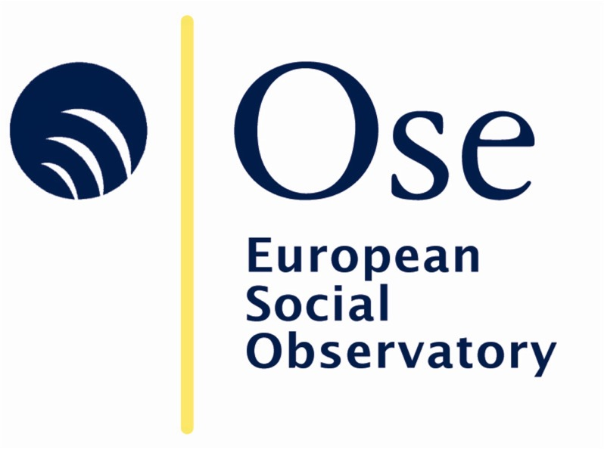 |  | 

The 17th edition of ‘Social Policy in the European Union: State of Play’ reports on recent EU and national social policymaking, with contributions from leading scholars pointing to a ‘crisis’. Tensions in the EU reached an unprecedented level: the migration crisis showed the EU the limits of its decision-making capacity, economic weakness continued to prevail, austerity policies and the badly handled socio-economic Greek crisis turned populations against the EU – and then came the Brexit vote.

This book argues that the centrifugal pressures within the EU and the EMU can be handled through a process of managed integration and disintegration. It maintains that the EU’s renewed focus on long-term unemployment is biased towards a ‘jobs first’ approach, contributing to the EU’s Janus-faced approach to the social dimension. It demonstrates that the austerity dogma has led to an erosion of social rights and makes a plea in favour of going ‘back to basics’ with regard to worker’s protection. Reflection and down-to-earth debate on the long-term integration of both EU migrants and refugees is required.

The political reality demonstrates that the EU project has been too narrowly focused on reciprocity, instead of solidarity. The harsh reality is that the European project can no longer be considered irreversible. The EU’s core values must therefore be reaffirmed with a view to creating a new common sense of purpose, including a more explicit commitment to equitable growth via a European Social Union.

Table of contents

